TASK ONE

**Launching Your EC2 Instance**

In this task, I launched an Amazon EC2 instance with termination protection enabled. The instance was deployed with a user data script that automatically installed and configured a simple web server.

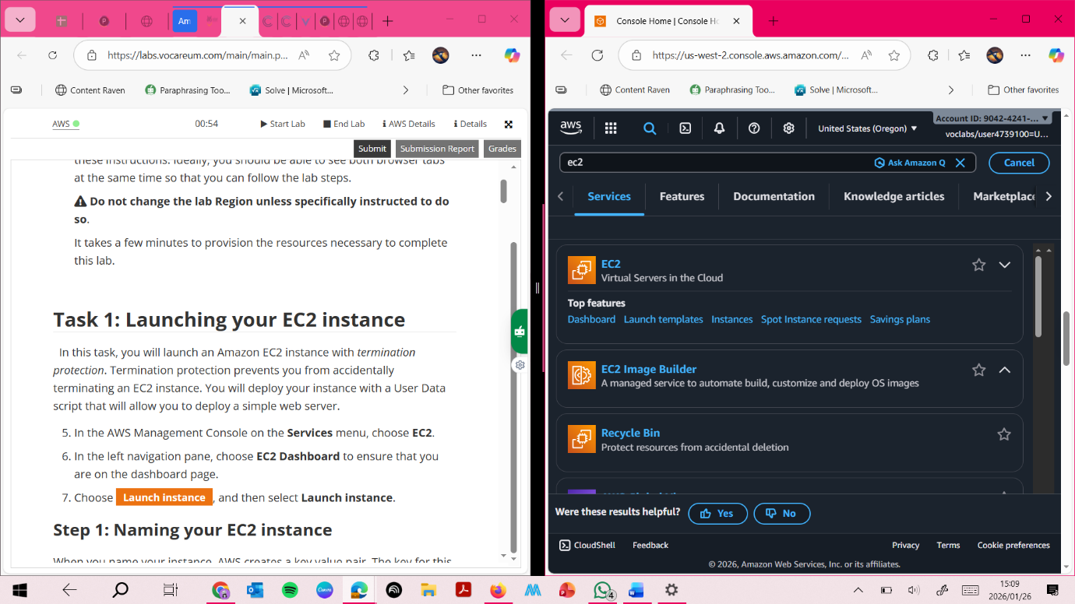

**Screenshot: EC2 Dashboard**

This screenshot shows the Amazon EC2 Dashboard where I began the process of launching a new EC2 instance.

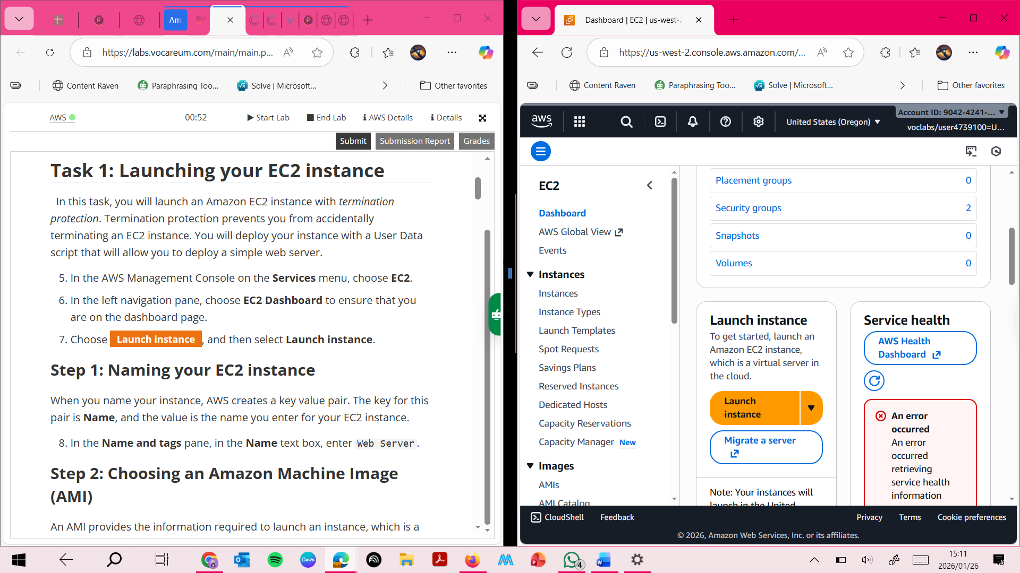

**Naming the EC2 Instance**

This screenshot shows the EC2 instance being named **“Web Server”**, which helps identify the instance within the AWS environment.

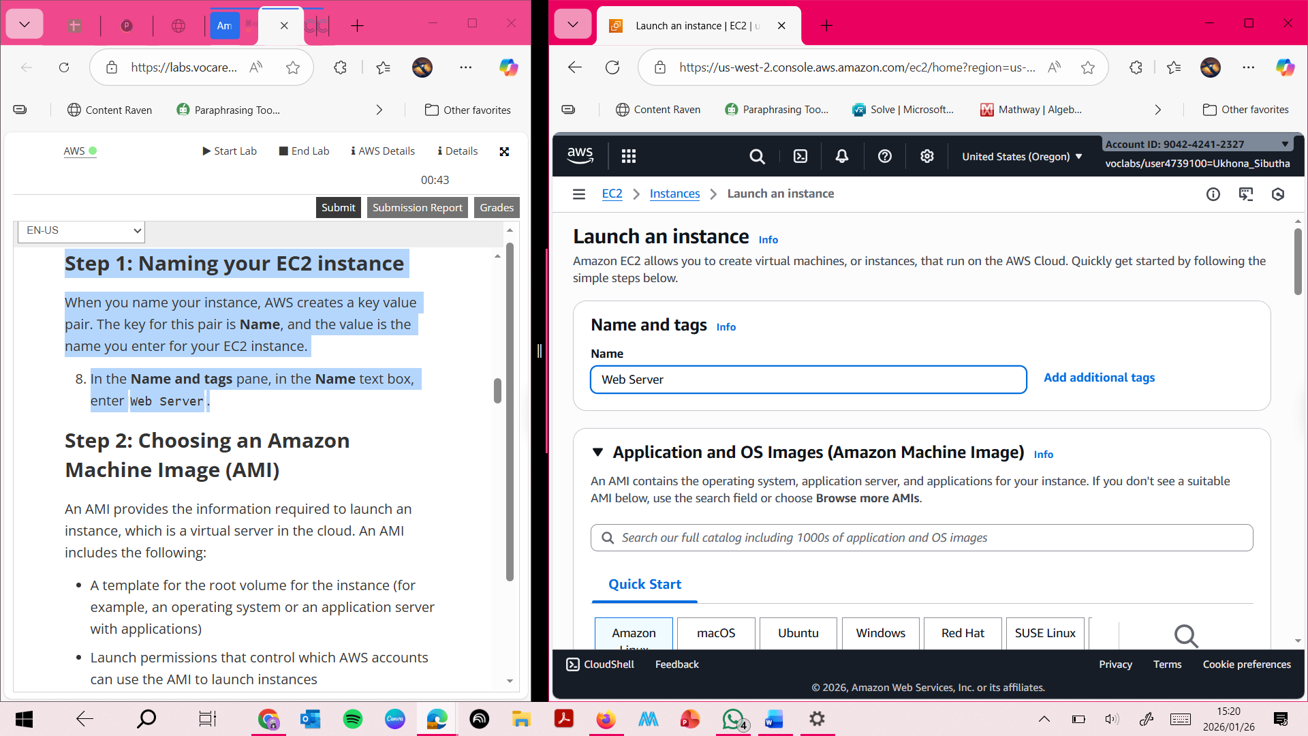

**Step 2: Choosing an Amazon Machine Image (AMI) Choosing an Amazon Machine Image (AMI)**

**This screenshot shows the selection of the Amazon Linux 2023 AMI, which provides the operating system and initial software configuration for the EC2 instance.**

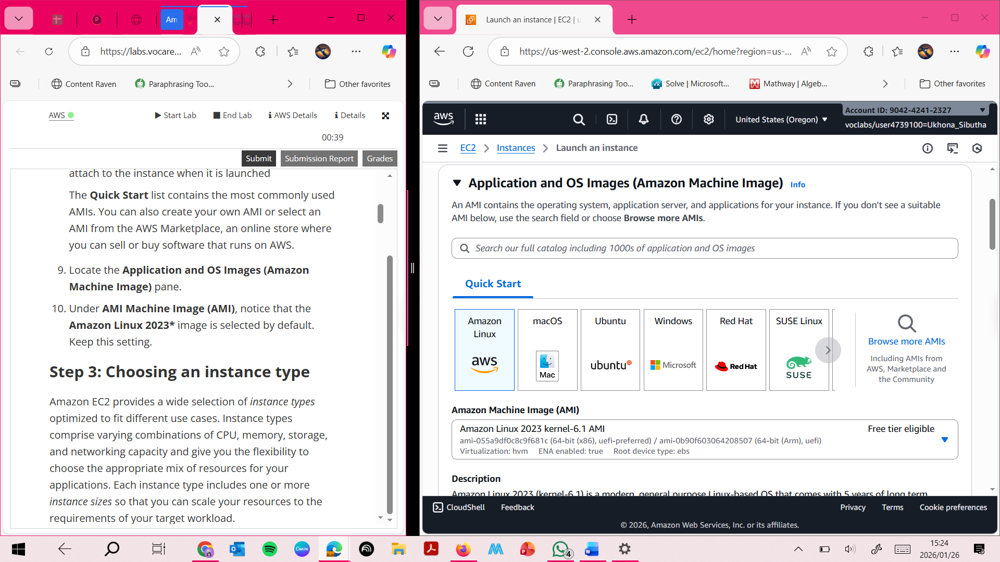

**Choosing Instance Type**

**This screenshot shows the selection of the t3.micro instance type, which provides 2 virtual CPUs and 1 GiB of memory.**

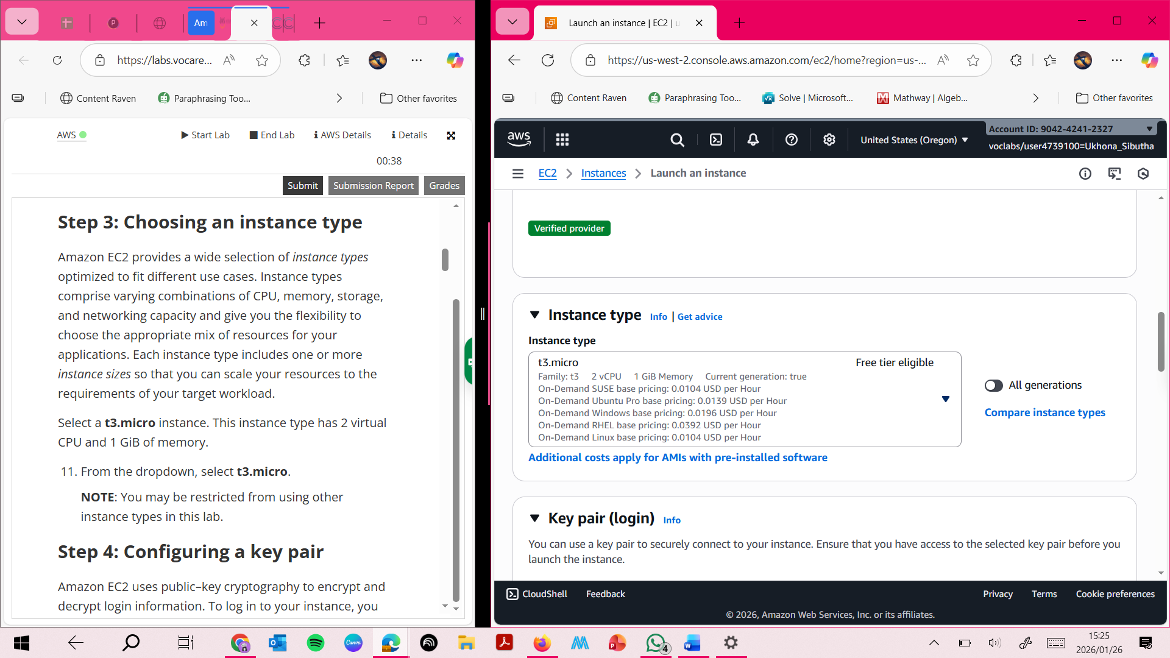

**Step 4: Confriguring a key pair:** **This screenshot shows that the instance was launched without a key pair, as logging into the instance was not required for this lab**

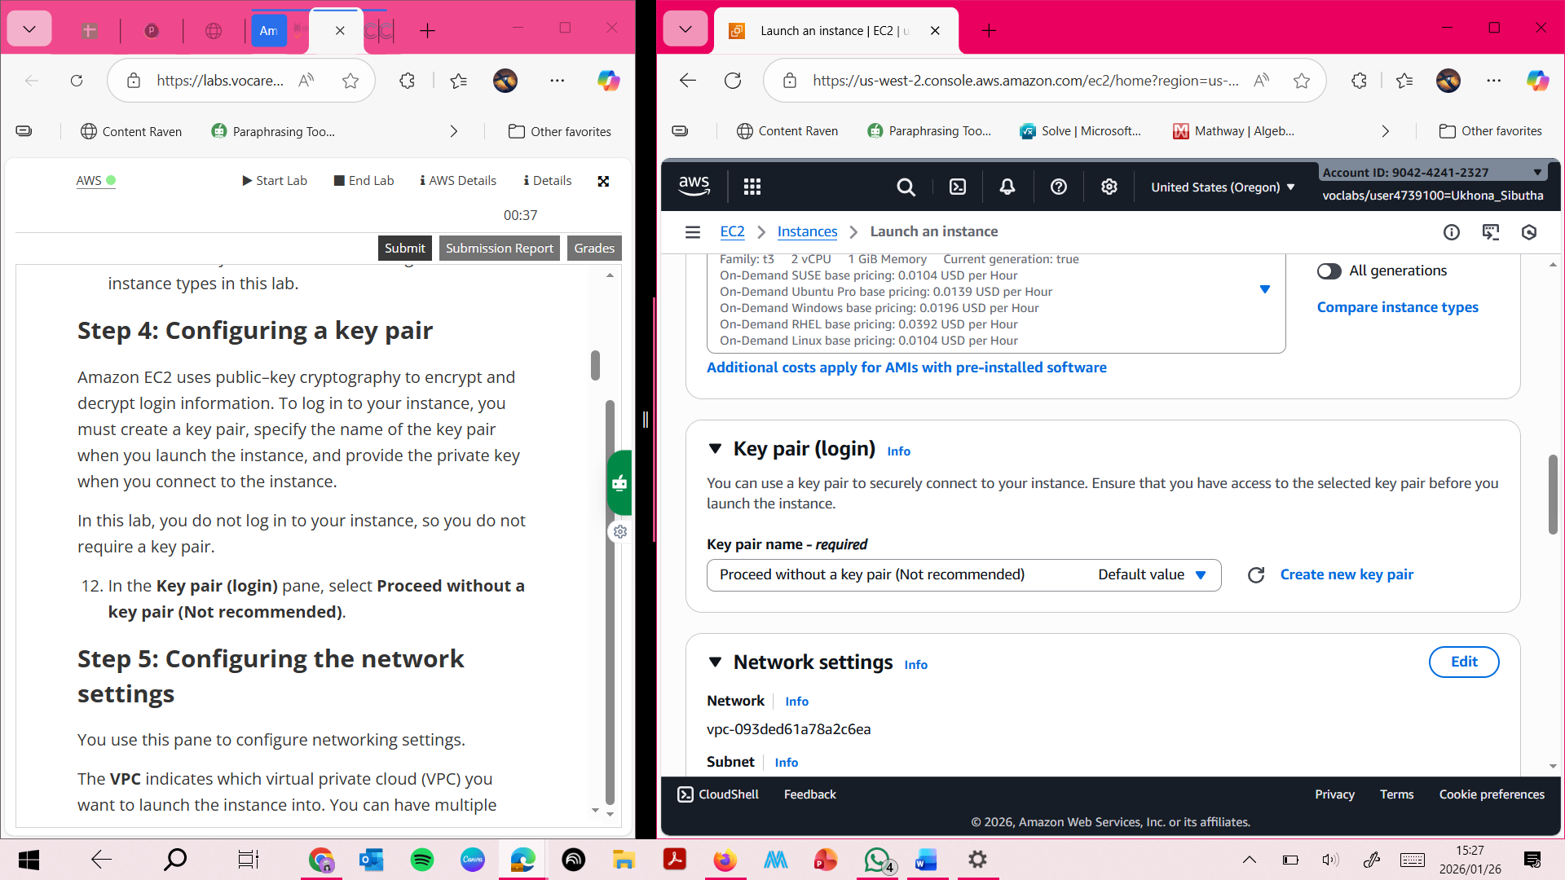

**Configuring the network settings:** **This screenshot shows the configuration of the Web Server security group, with SSH access removed to improve security.**

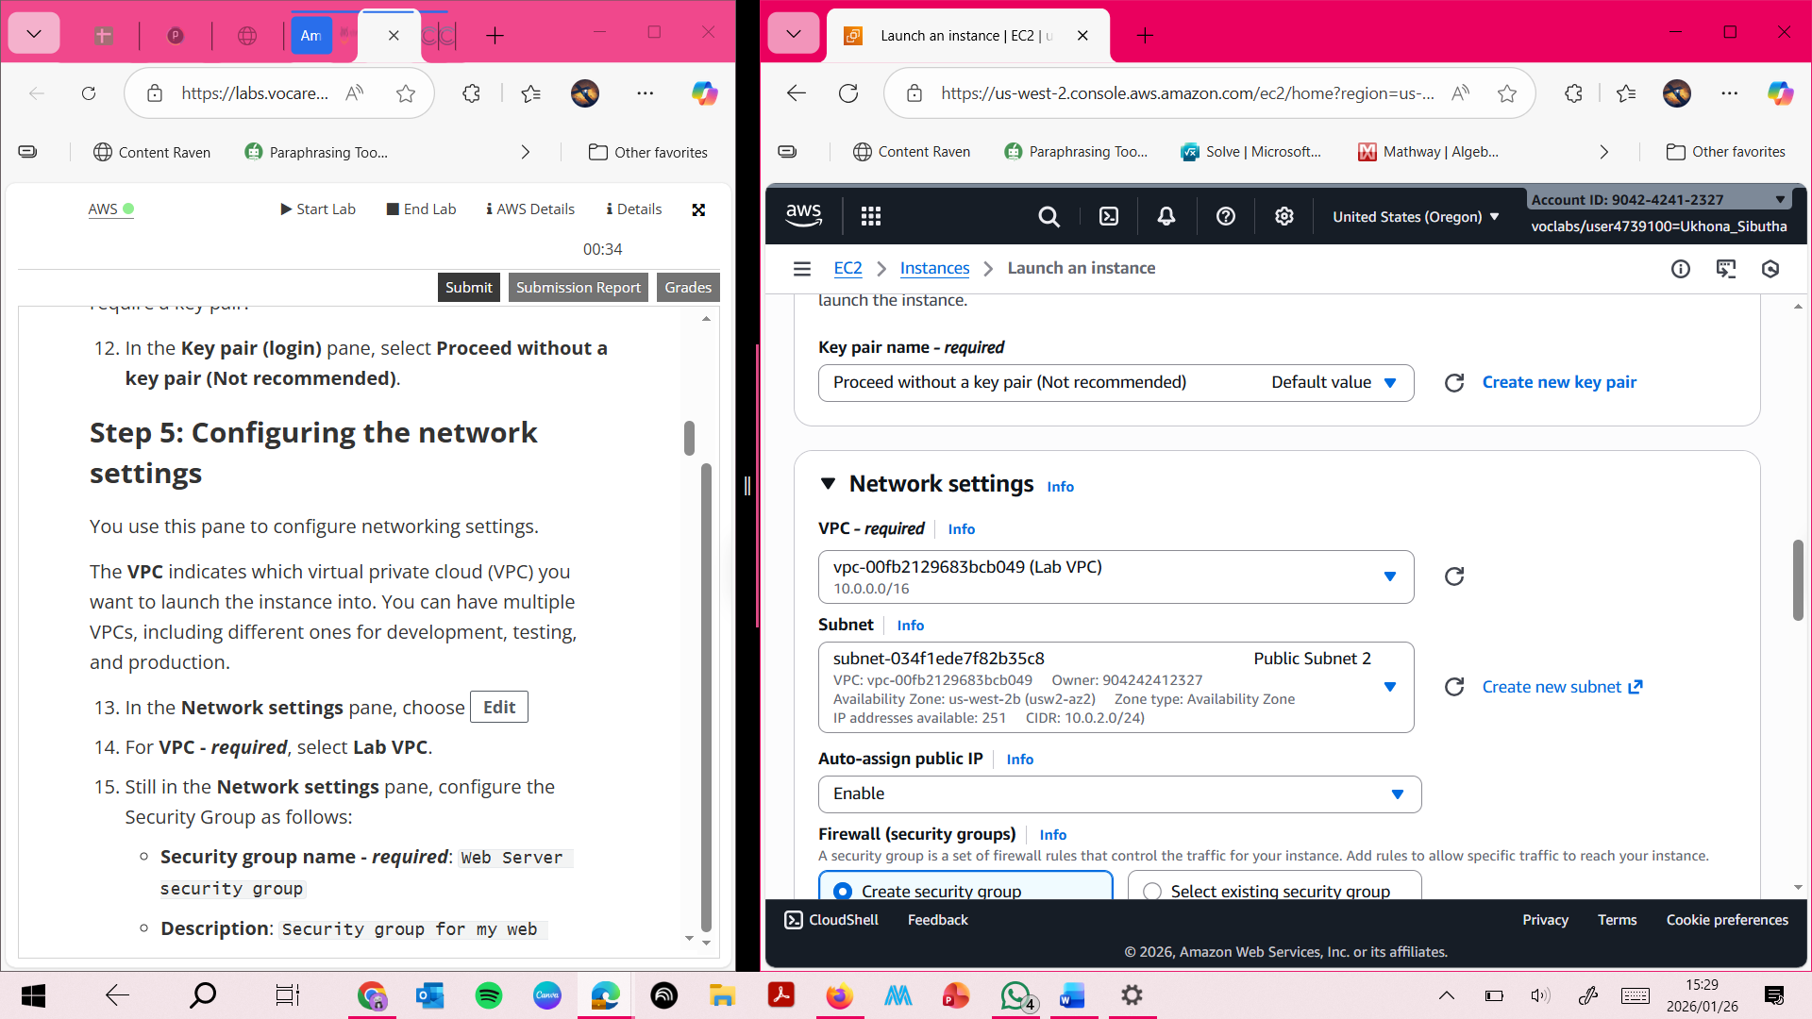

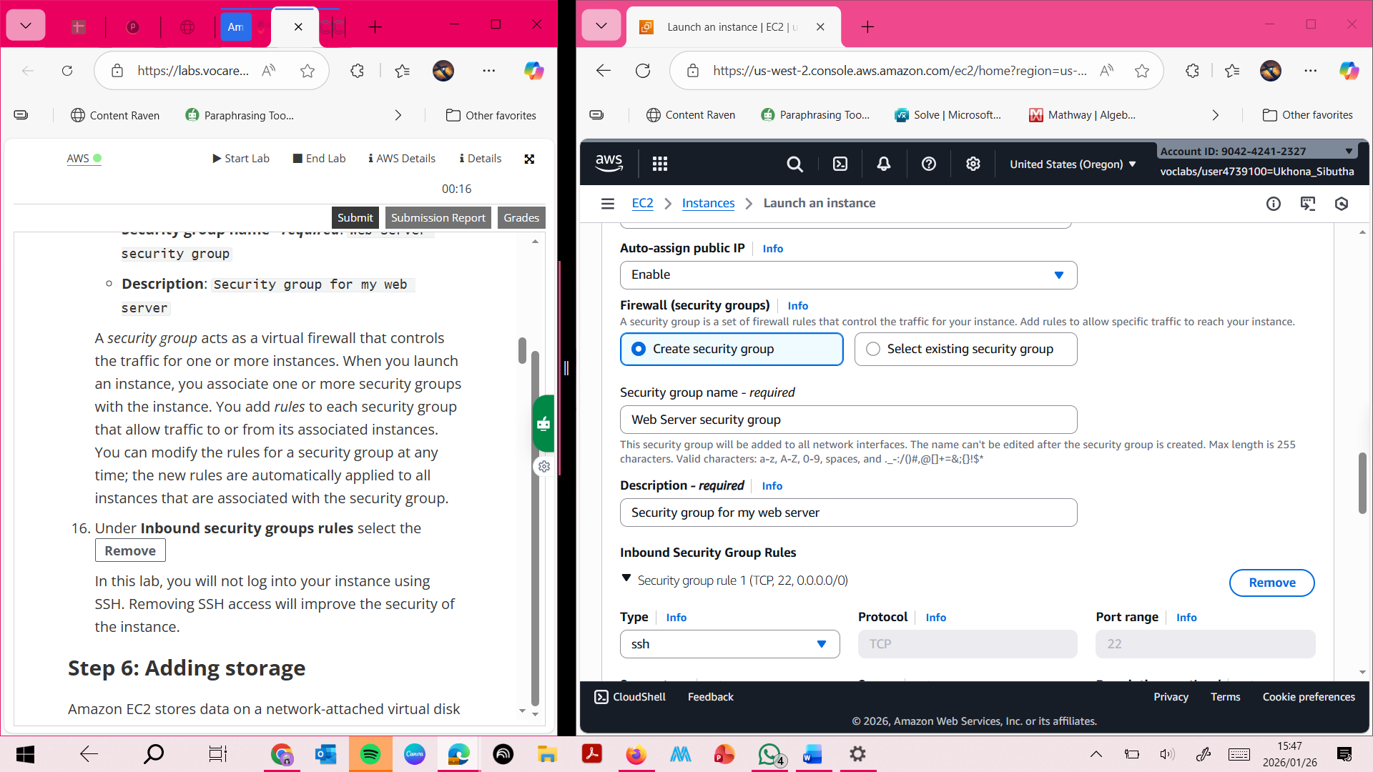

**Adding storage**

**This screenshot shows the default 8 GiB Amazon EBS root volume being used for the EC2 instance.**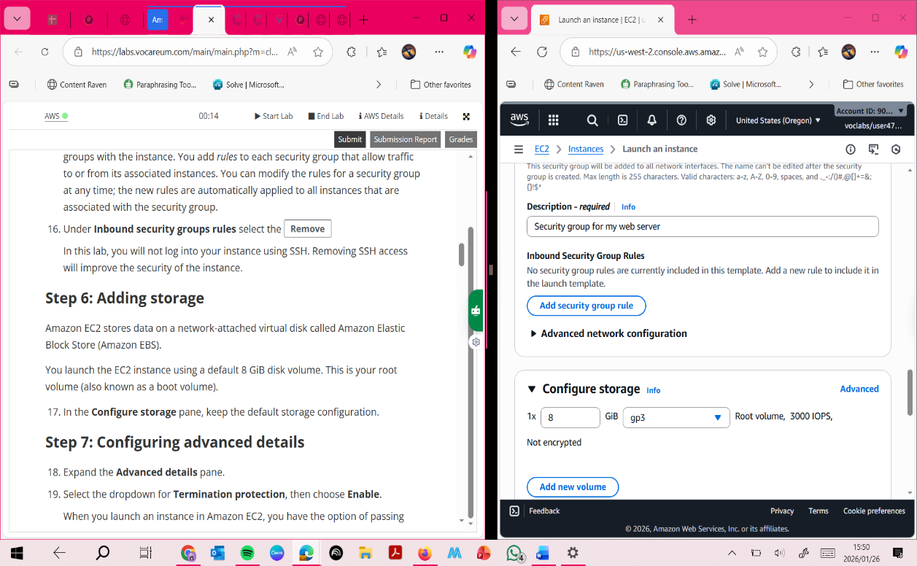

**Step 7 : Configuring advanced details This screenshot shows termination protection being enabled and a user data script being added to automatically install and configure an Apache web server.**

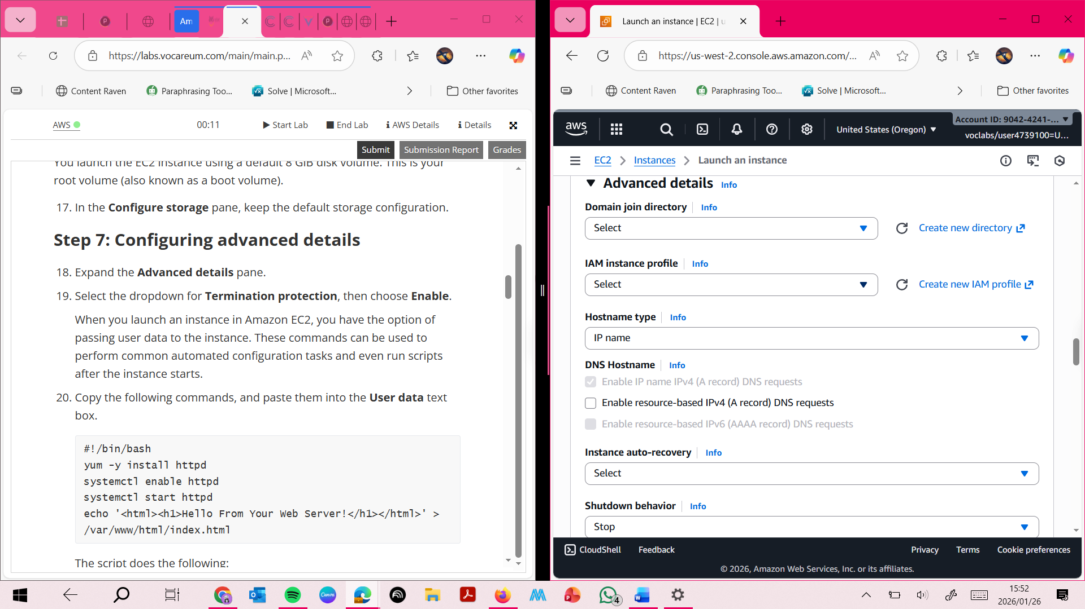

**This screenshot shows termination protection being enabled and a user data script being added to automatically install and configure an Apache web server.**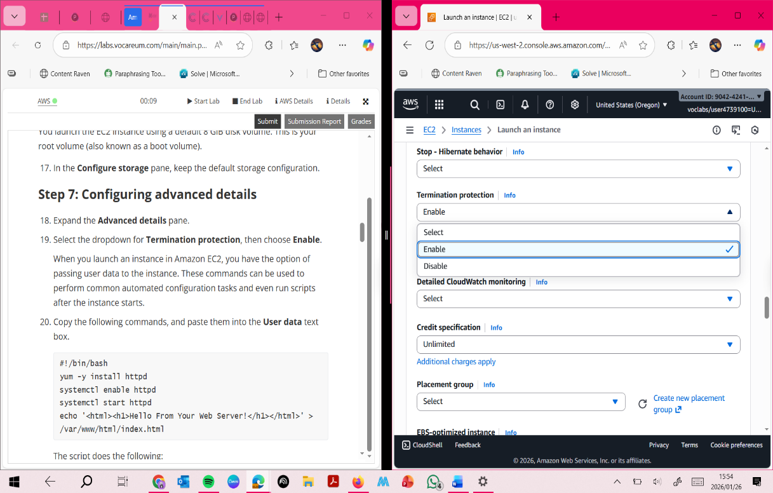

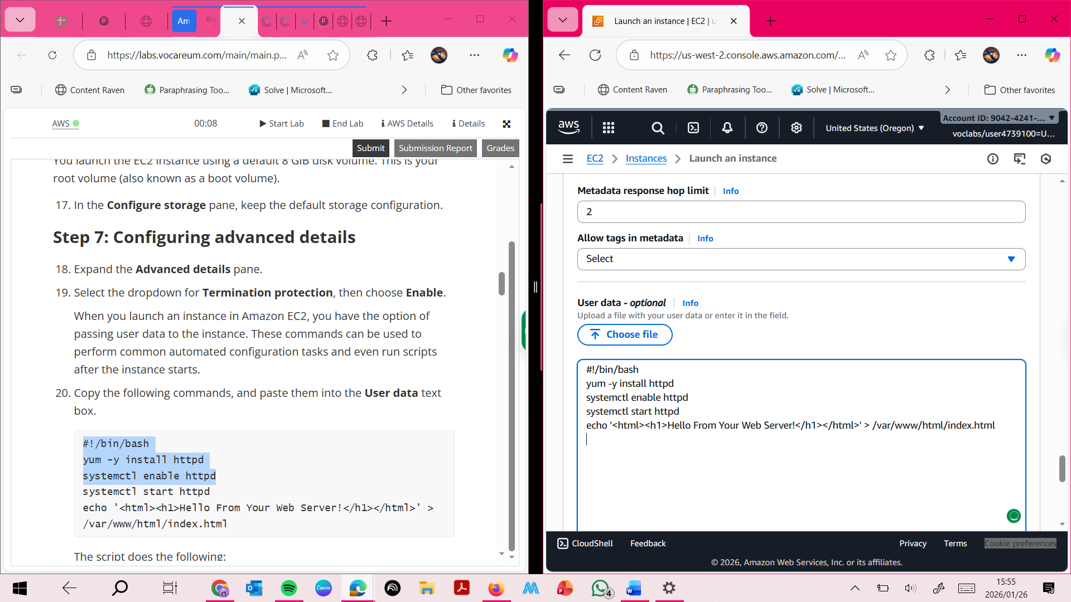

**Step 8: Launching an E2 INSTANCE**

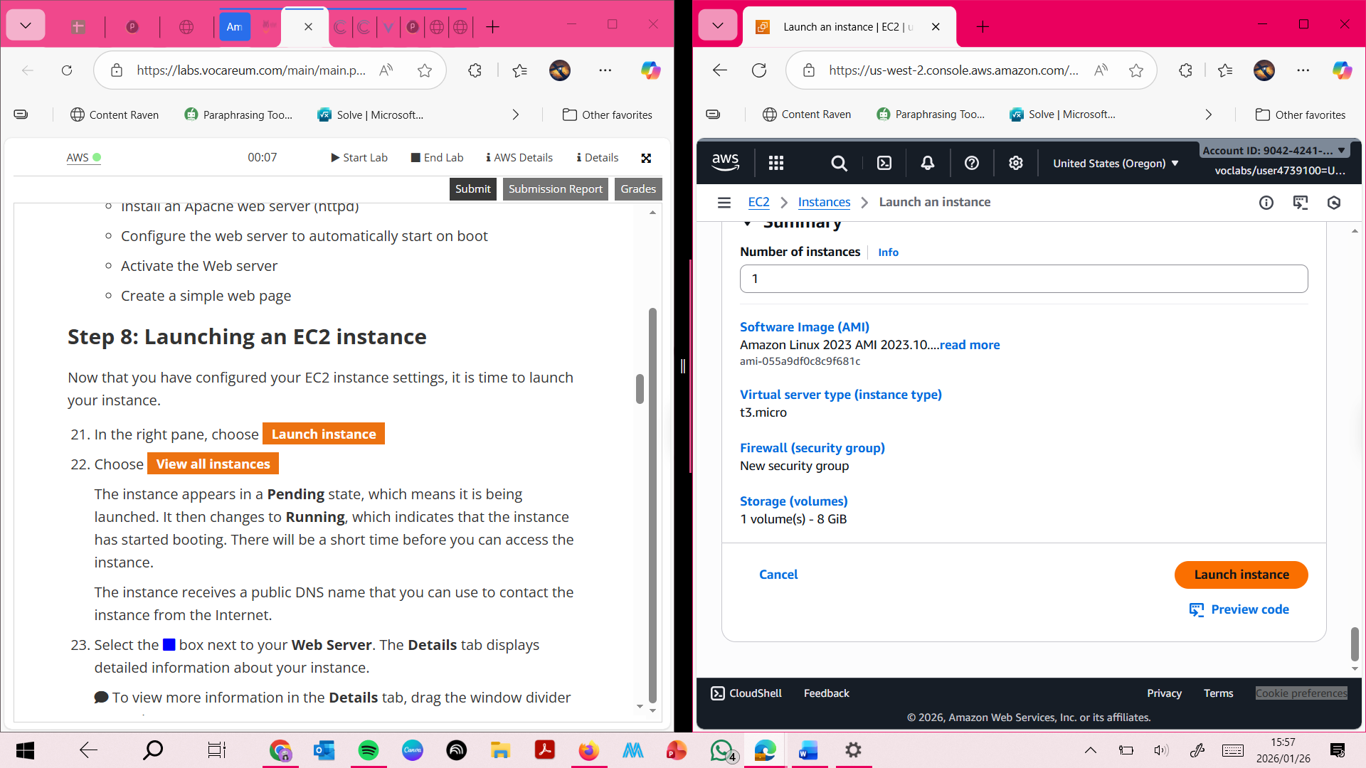

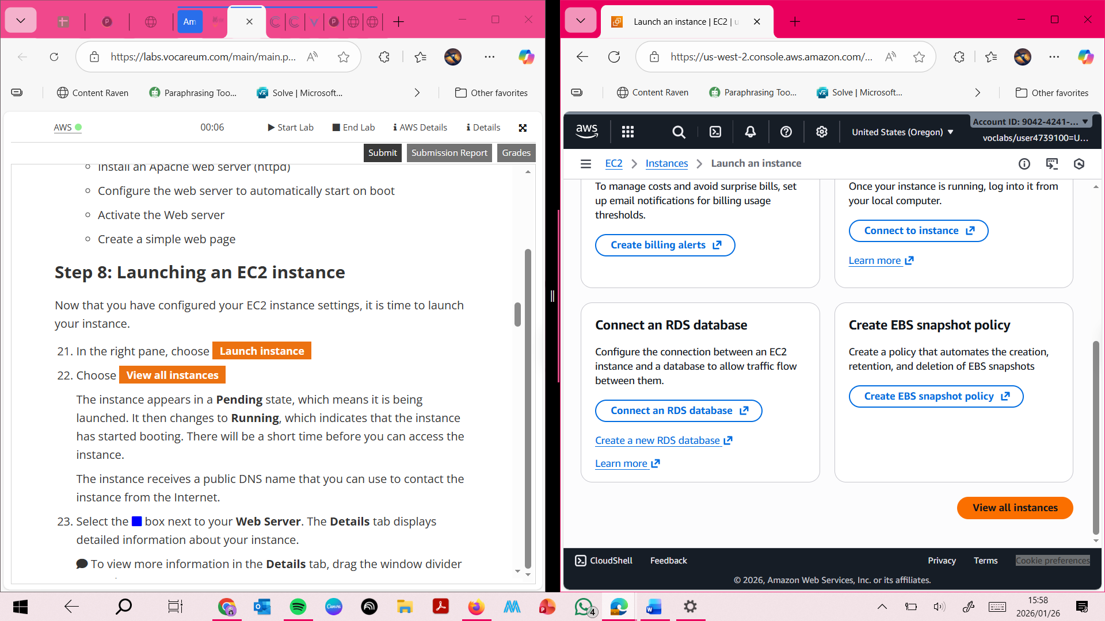

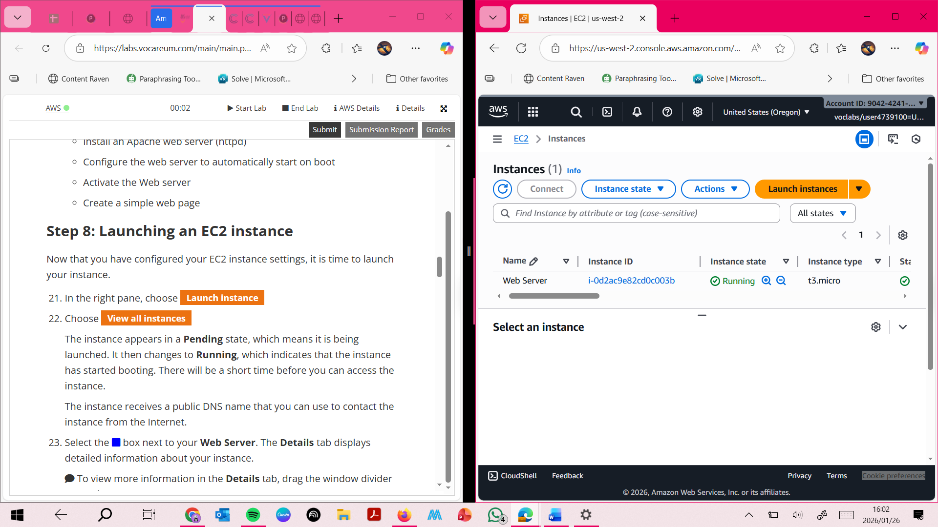 **This screenshot confirms the successful launch of the EC2 instance and shows the instance state changing from Pending to Running.**

**Task 2**

**This screenshot shows that both System reachability and Instance reachability status checks have passed.**

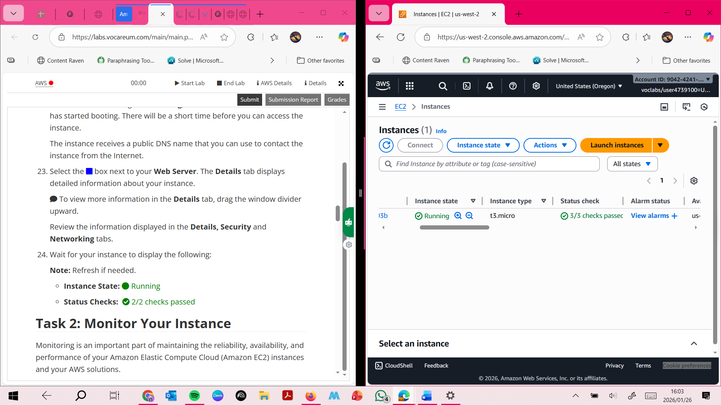

**This screenshot shows Amazon CloudWatch metrics used to monitor the performance and health of the EC2 instance**

**+**

**This screenshot displays the EC2 instance console screenshot, which can be used for troubleshooting when an instance cannot be accessed.**

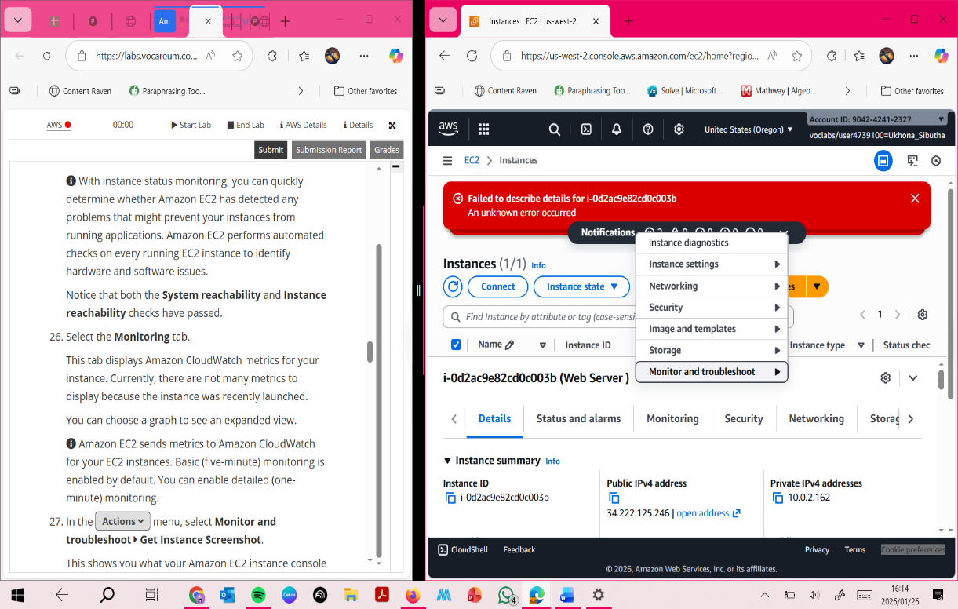

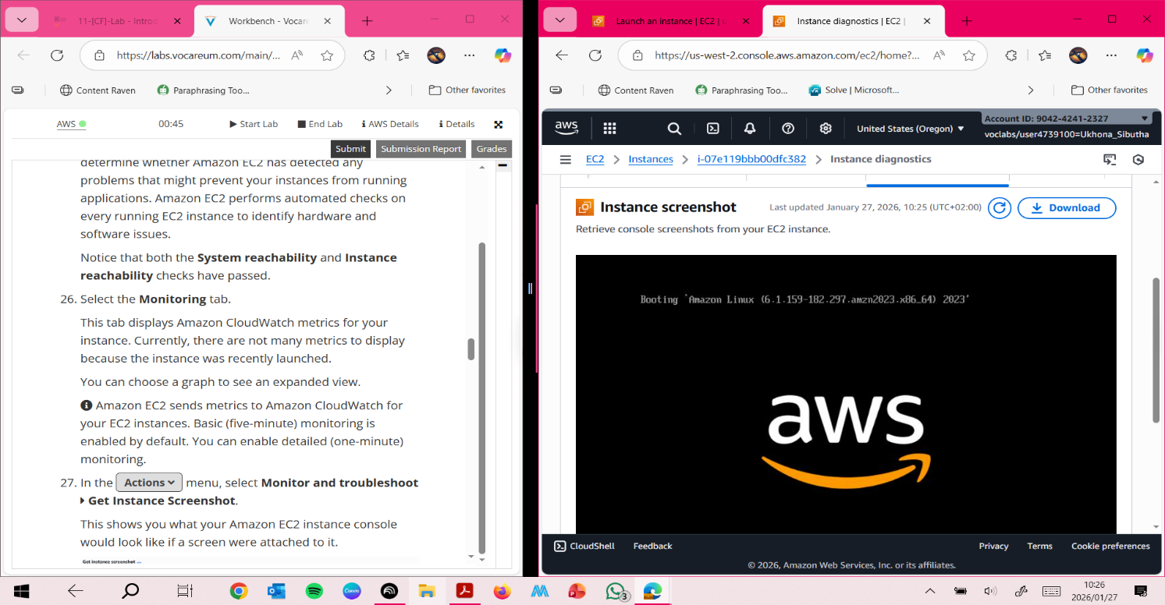

**Task 3**

**Updating security group and access the web server**

**This screenshot shows that the web server could not be accessed because inbound HTTP traffic was not yet allowed.**

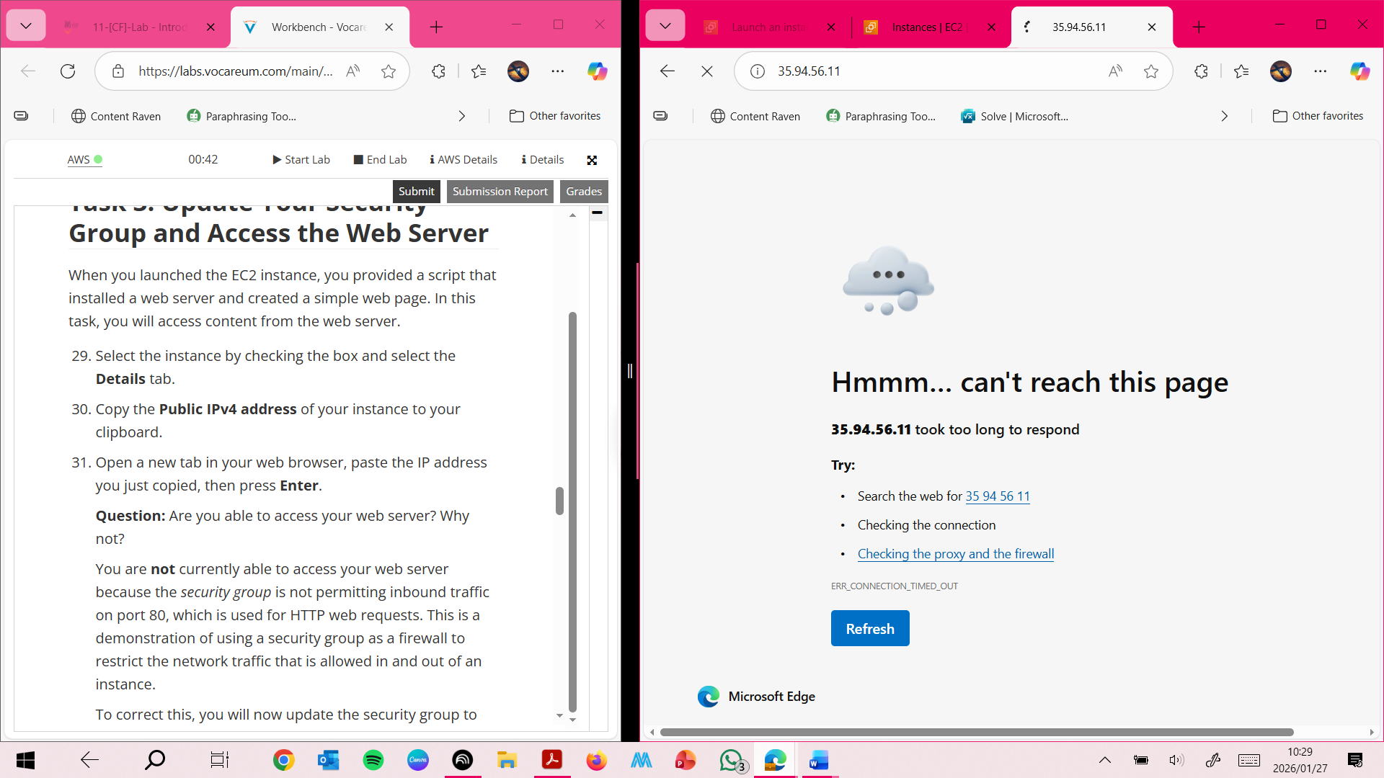

**This screenshot shows the inbound rule being added to allow HTTP traffic on port 80 from Anywhere-IPv4.**

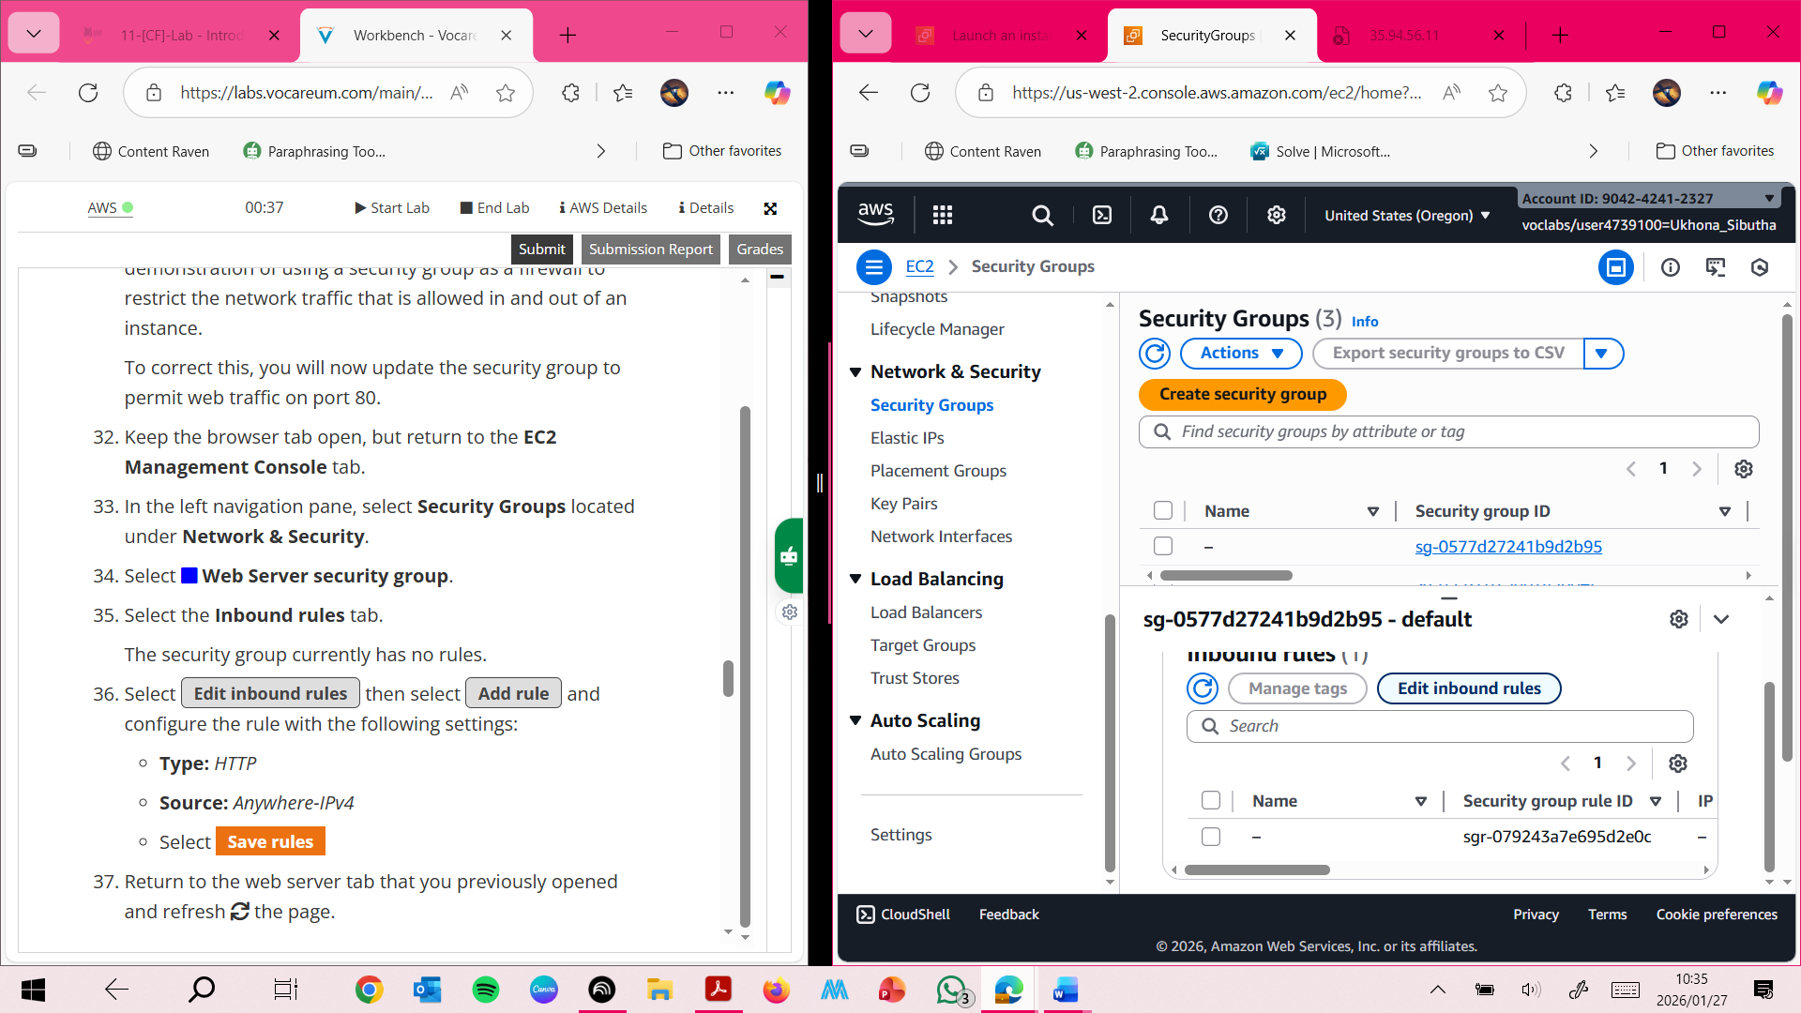

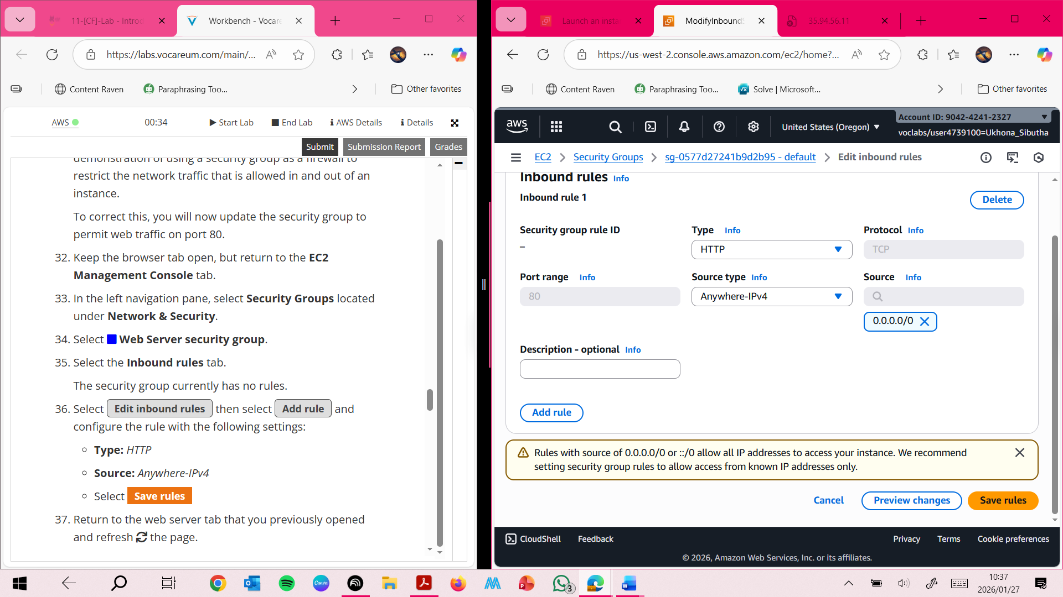

**This screenshot shows the message “Hello From Your Web Server!”, confirming that the web server is accessible after updating the security group.**

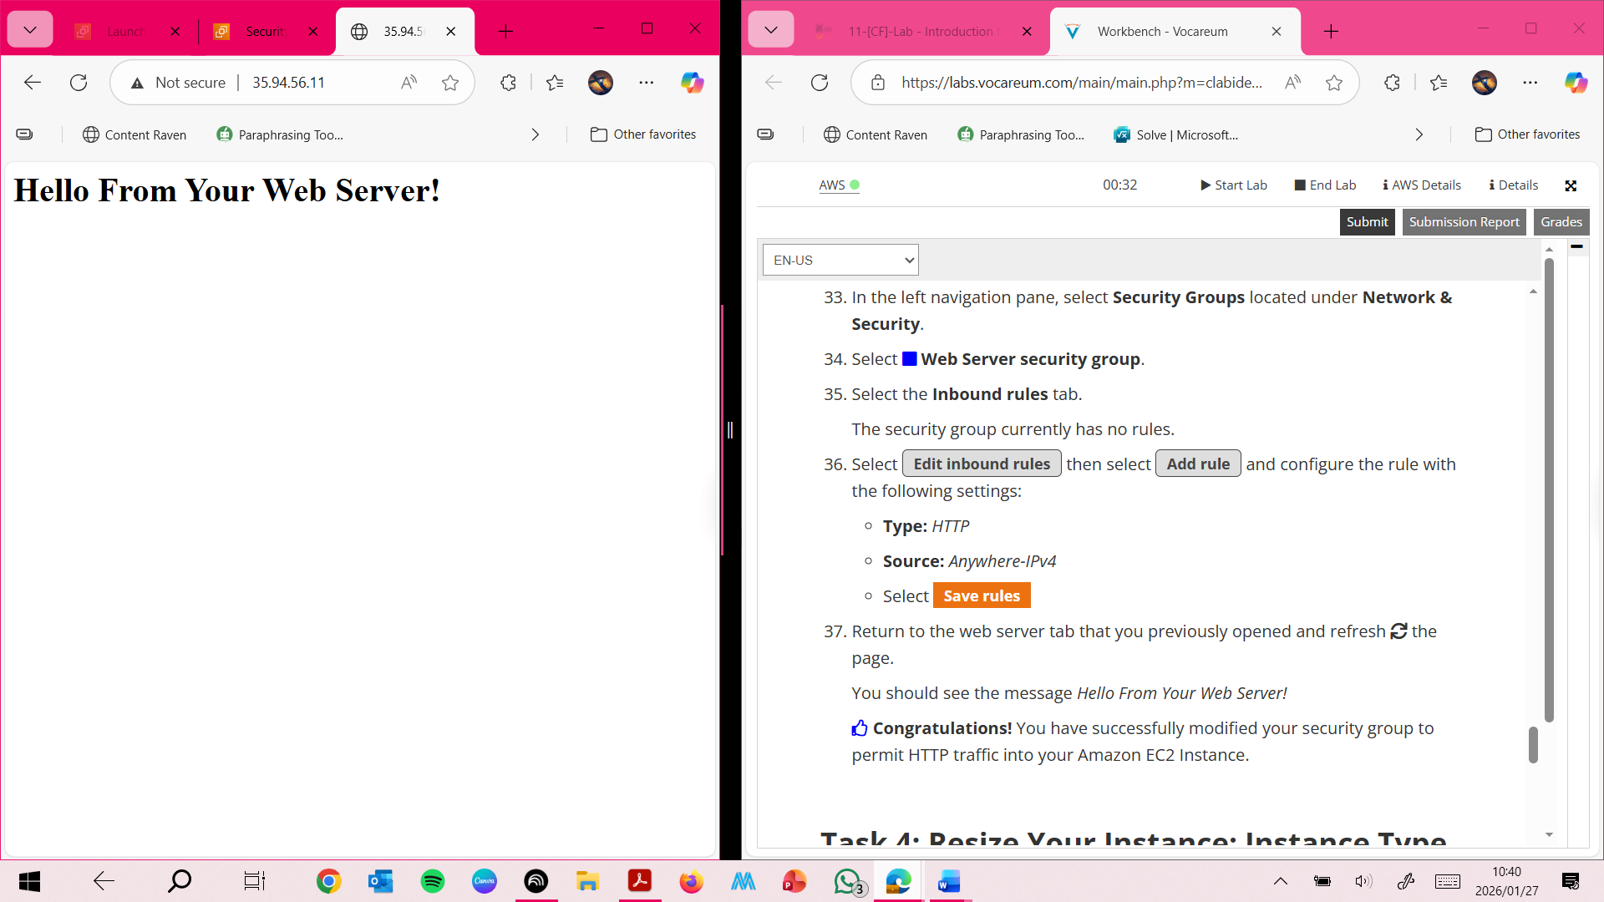

**Task 4 : Resizing the instance - Instance Type and EBS Volume**

**This screenshot shows the EC2 instance being stopped before resizing, which is required to modify the instance type.**

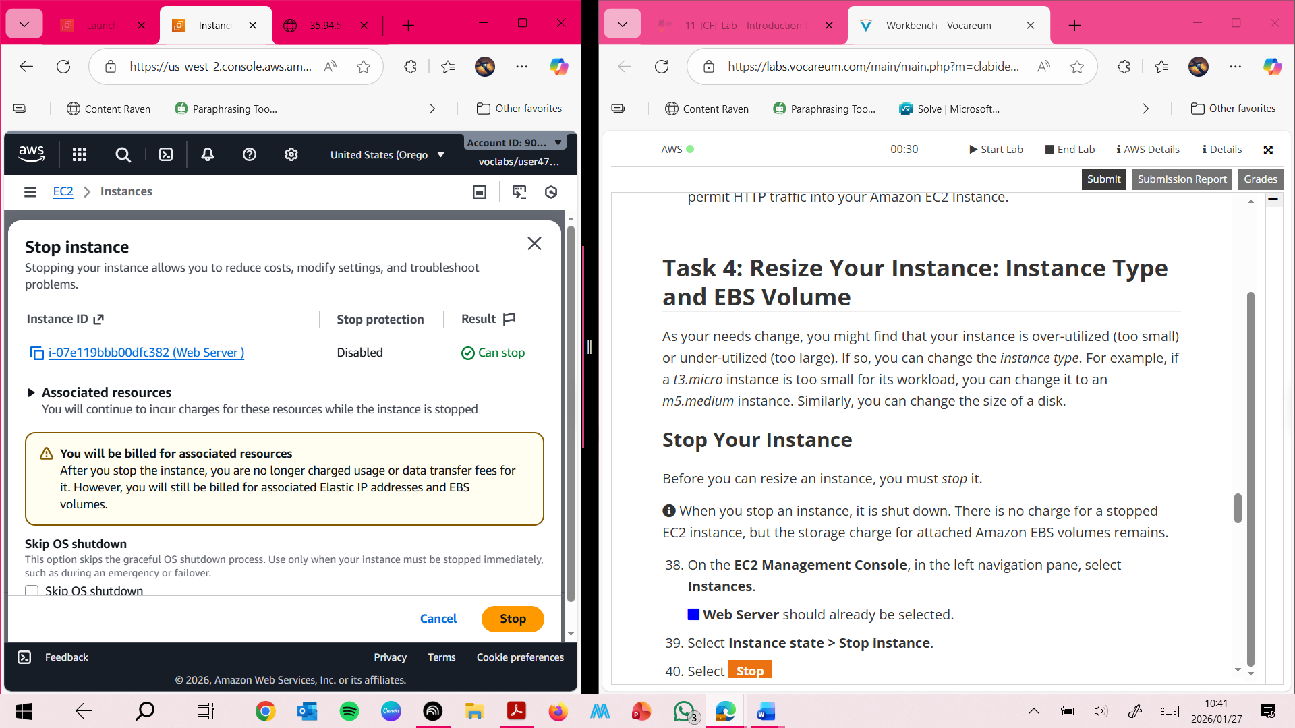

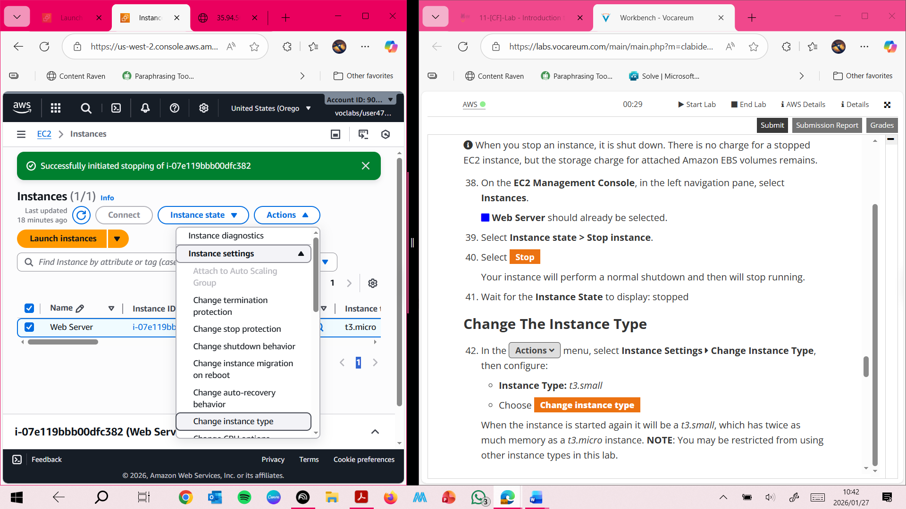

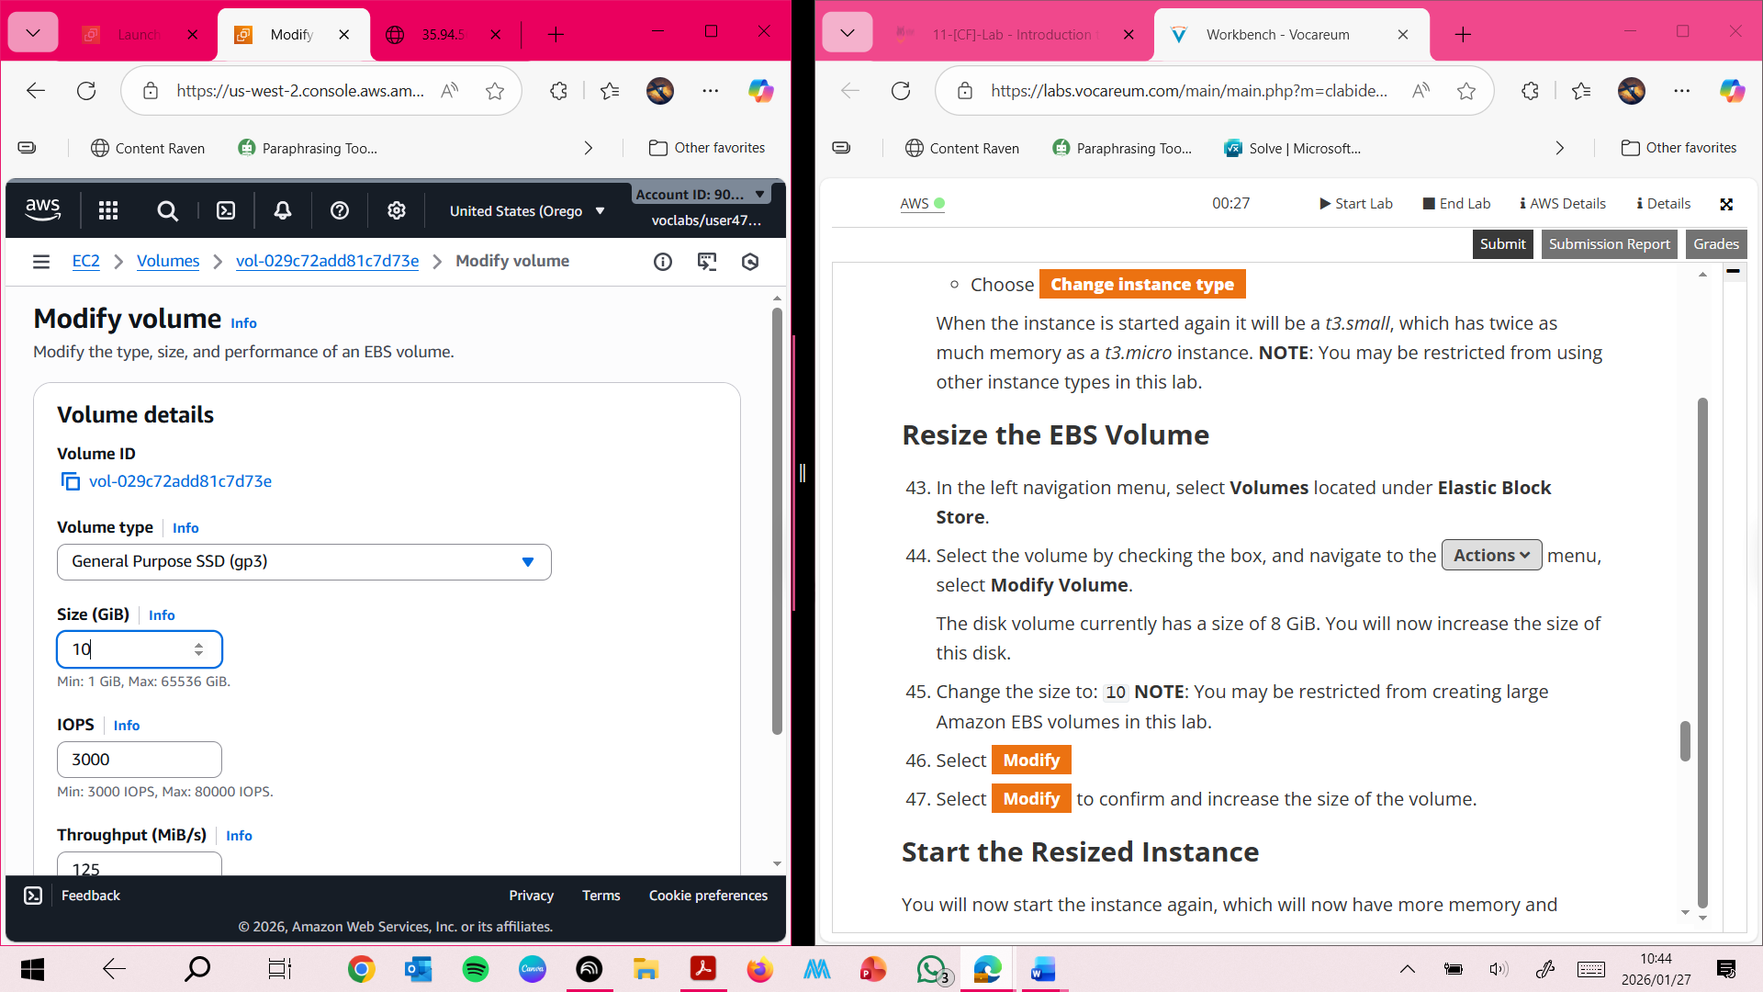 **This screenshot shows the instance type being changed from t3.micro to t3.small, providing additional memory.**

